Inner Perivitelline Layer Sperm Penetration Assay
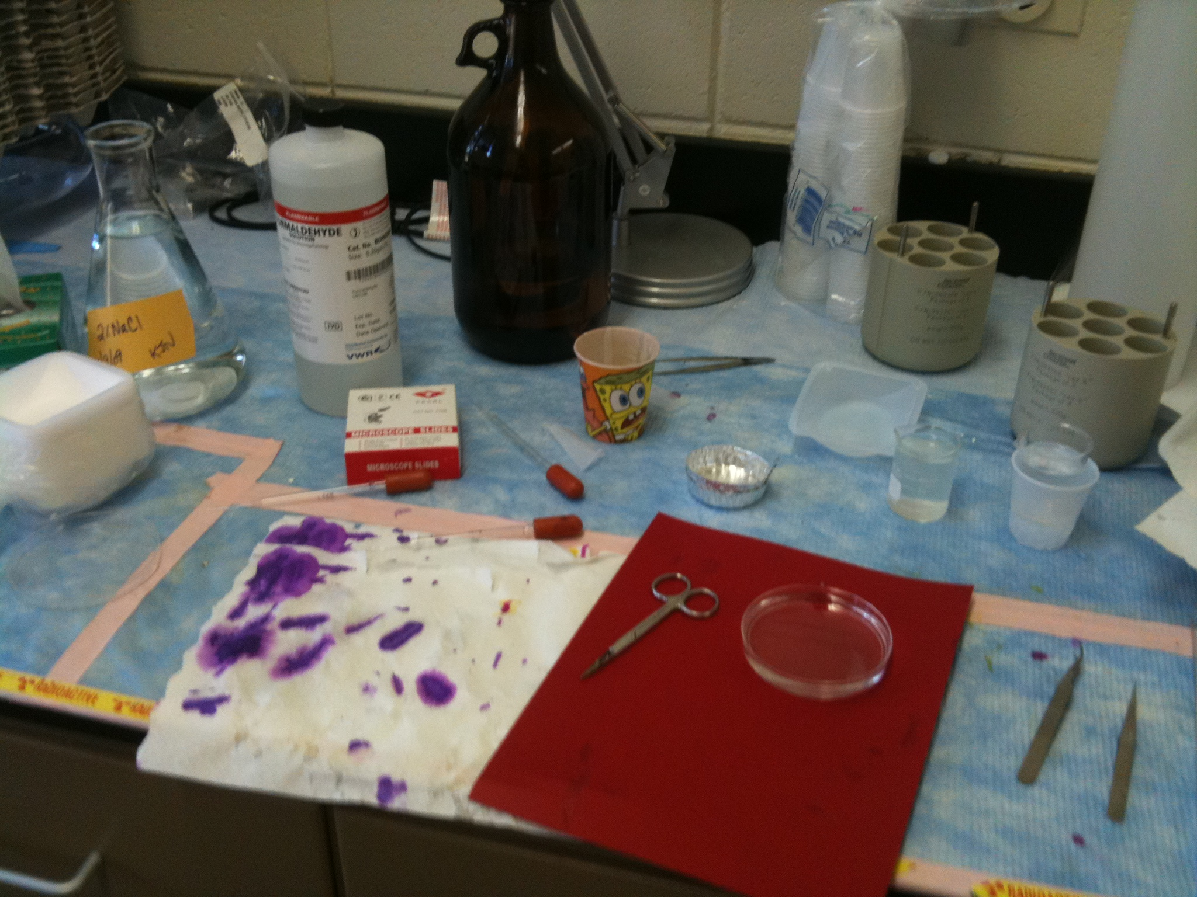
Protocol
Materials
2% NaCl solution
Krebs reagent (see other protocol) -OR- PBS 1x (see below)
Small aluminum pans (Fisher #08-732)
Small scissors
Forceps
20mL beaker (x2)
Petri dish (x2)
Frosted microscope slides (Fisher #12-550-34)
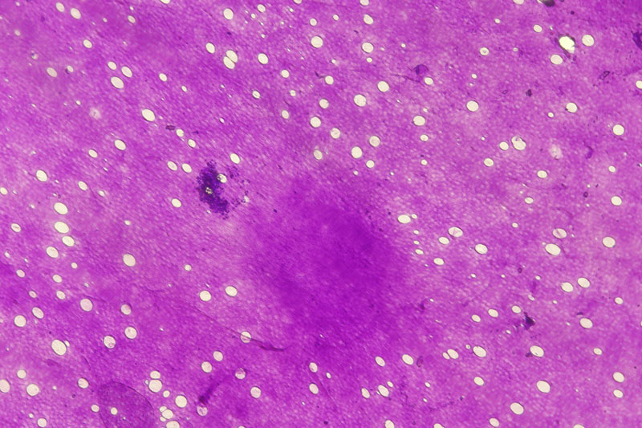
3% Formaldehyde (37%: Fisher #F79-500)
Schiff’s Reagent (Sigma #S5133)
Kim Wipes

PBS 1x
- Add the following ingredients at 800mL dH₂O:
NaCl: 8.0g
KCl: 0.2g
Na₂HPO₄: 1.44g
KH₂PO₄: 1.24g
- pH solution to 7.4 using HCl
- Bring up solution to 1L with dH₂O

Procedure
- Break open egg over a waste container and collect yolk while removing excess albumin
- Place egg in pan with germinal disc (blastoderm) facing up
- Blot yolk dry with Kim Wipe
- Pour 2% NaCl solution over yolk making sure the entire yolk is wet (make sure not to tear the perivitelline layer)
- Use scissors to cut a square around the germinal disc
- Use forceps to remove the membrane with as little yolk as possible
- Rinse the membrane in first beaker filled with Krebs (or PBS)
- Repeat rinse in a second beaker filled with Krebs (or PBS)
- Place membrane in petri dish containing Krebs (or PBS)
- Carefully float membrane onto the slide and wick dry excess fluid
- Place 3-4 drops of 3% formaldehyde on membrane (just enough to cover the membrane). Do not move membrane after addition of formaldehyde
- As quickly as possible, place 2-3 drops of undiluted Schiff’s reagent on the membrane
- As soon as the membrane turns purple blot excess Schiff’s reagent with paper towel
- Lean slide against something so that it can dry while allowing excess fluid to drain off
- Allow slide to dry then count the number of holes at 40x
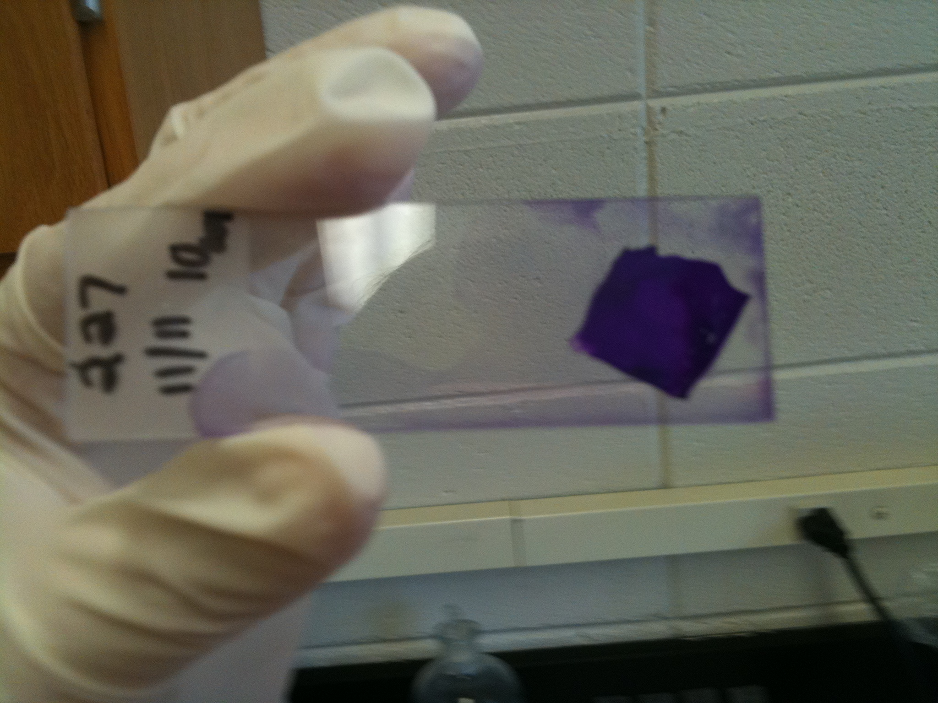

Determination of field of view area (FOV):

FOV diameter (mm) = Field of view# on eyepiece
Magnification of objective x optivar

This is diameter, divide by 2 to get the radius then input radius into A = πr²

